Project Design Phase-II
Data Flow Diagram & User Stories
Date | 28 September 2026
Team ID | 6ab221fbe880316a482c6241
Project Name | Script-Controlled ACL – Restrict Record Access Based on Field Value
Maximum Marks | 4 Marks
Data Flow Diagrams:
A Data Flow Diagram (DFD) is a traditional visual representation of the information flows within a system. A neat and clear DFD can depict the right amount of the system requirement graphically. It shows how data enters and leaves the system, what changes the information, and where data is stored.
Example: DFD Level 0 (Script-Controlled ACL)
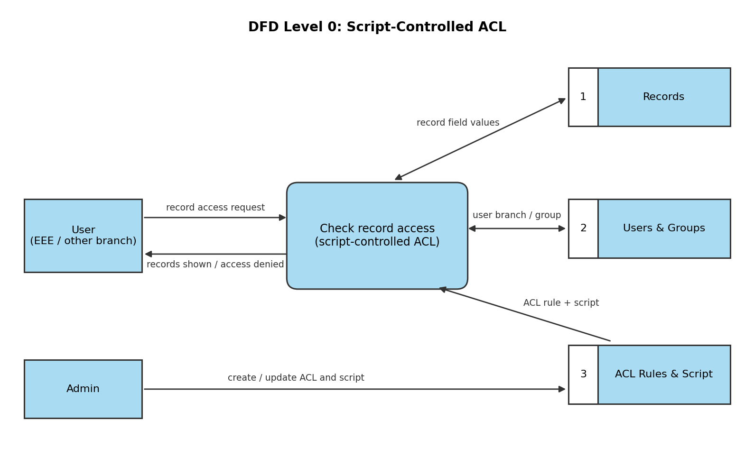
Flow:
1. The user (EEE or other branch) requests access to a record.
2. The ACL script reads the record field values from the Records table.
3. The script checks the user's branch / group in the Users & Groups table.
4. The ACL rule and script created by the admin are read from the ACL Rules & Script store.
5. The record is shown if the user belongs to the EEE branch (or is an admin); otherwise access is denied.

User Stories
Use the below template to list all the user stories for the product.
User Type | Functional Requirement (Epic) | User Story Number | User Story / Task | Acceptance criteria | Priority | Release
Administrator | Access Control Setup | USN-1 | As an admin, I can create the records table with a Branch field. | Table and field are visible in the instance | High | Sprint-1
Administrator |  | USN-2 | As an admin, I can create the EEE group and add EEE branch users to it. | Users appear as members of the EEE group | High | Sprint-1
Administrator | ACL Configuration | USN-3 | As an admin, I can create a read ACL with a script that checks EEE branch membership. | ACL is active on the records table | High | Sprint-2
Administrator |  | USN-4 | As an admin, I can allow the admin role to bypass the branch check. | Admin can view all records | Medium | Sprint-2
EEE Branch User | Record Access | USN-5 | As an EEE branch user, I can view the EEE records. | Records are shown in the list and form | High | Sprint-2
Non-EEE User |  | USN-6 | As a non-EEE user, I cannot view the EEE records. | Records are hidden in the list, form and API | High | Sprint-2
Tester | Testing | USN-7 | As a tester, I can impersonate EEE, non-EEE and admin users to verify the ACL. | Results match the expected access | High | Sprint-3
Administrator | Deployment | USN-8 | As an admin, I can capture the changes in an Update Set and deploy it. | Update Set is committed without errors | Medium | Sprint-4

